|  |  |  |
| --- | --- | --- |
| Rippleside Elementary Newsletter | | |
| September 2022 | | |
| Welcome to Rippleside! | | |
|  | | |
| Dear Parents/Guardians: **Welcome back to school!**  At the beginning of our day students will be dropped off at the same locations as last year. Parents/guardians who are dropping students off will drop them off in front of Woock Field. Buses will be dropping students off in front of Rippleside. Students may be dropped off starting at 7:50 AM. All students will enter through the main entrance. When students enter the building, after 7:50 AM, they will go directly to the cafeteria until the 8:00 AM bell, at that time students may either stay in the cafeteria to eat breakfast or go directly to their classroom. All kindergarten students will go directly to their classroom at the 8:00 AM bell as they will be eating breakfast with their classmates. If your student needs to be dropped off prior to 7:50 AM, they must be enrolled in Kid’s Club. Kid’s Club is open for students at 6:45 AM. We do have a new location for our Kid’s Club room, it is located down by our Early Childhood Center.  Breakfast will be served from 8:00 – 8:25AM. As a community we are urging all families in the district to complete an Application for Educational Benefits (free and reduced lunch application) regardless of income. Our district receives funding based on applications received so it is crucial that you complete them regardless of whether or not you think you will qualify. You will not receive P-EBT benefits or discounted iPad insurance if a qualifying application is not on file for your family.  Our day will end at 3:04 PM for students. Buses will leave Rippleside at 3:10 PM and parent pick up will begin. Walkers will also be dismissed at 3:10 PM. Parent/guardian pick up will be operated the same as last year. K-3 students will be dismissed from Door #2. Students in grades 4-6 will be dismissed from the main entry, Door #1. We ask that parents/guardians that are picking students up remain in their vehicle and please pull forward as directed by the staff supervising pick up. Our teachers provide instructions until the end of the day so we ask that you minimize picking up prior to 3:10 PM.  Thank you for being committed to and supporting an excellent educational experience for the Rippleside community and the community of Aitkin. Please contact me either by phone or email if you have further questions.  Sincerely,  Andrew Dokken, Principal  Andrew G. Dokken  Rippleside Elementary Principal |  | Logo  Description automatically generated  Inside this edition:   * Nut Aware & Attendance * Transportation, PAC, Kid’s Club * Picture Day & School Labels Programs * Volunteers & School Meals * PTO News * School Calendar * Community Ed Programs * Lunch Menu * Adopt a Teacher (PTO) |
|   225 2nd Avenue SW., Aitkin, MN 56431  [**www.isd1.org/rippleside**](http://www.isd1.org/rippleside)  **Phone: 218-927-4838**  **Fax: 218-927-4608** |  |

Welcome back Gobblers!

|  |  |  |  |
| --- | --- | --- | --- |
| **We are a peanut aware school**  Aitkin Public Schools has developed its own policy regarding food brought into school facilities. Food consumed within school facilities must be prepared within the school, or commercially prepared. Distribution and serving of food items, including “treats”, which are prepared in individual homes are not allowed.  Increased Federal and State regulations prohibit the use of school coolers and freezer space except for food service items. For this reason, we ask parents to avoid frozen treats for birthdays unless you have made prior arrangements with your child’s teacher and are able to bring the frozen item at snack time.  Our Wellness Committee encourages parents to consider sending snacks and treats that may be higher in nutritional value. Some examples of these are: fruit, cheese and yogurt.  ***\*Please contact our nurse’s office and kitchen if your child has food allergies or sensitivities.\****  *Food Brought into School* | | | |
|  | | | |
|  |  |  | |
| ***Attendance Expectations***  If at all possible, we encourage families to schedule non-emergent appointments outside of school hours so your student may participate in the complete instructional day.  If you have any concerns or questions regarding your student’s attendance at any point throughout the school year, please contact the main office at 218-927-4838.  Daily attendance and participation in classroom lessons is vitally important to the overall success of every student. We strongly encourage students to attend school every day. In the event of an illness, family emergency, scheduled vacation, funeral or other pressing matter it is required that the Rippleside Office be notified of the reason for the absence so that it can be recorded. Absences can be excused up to two days after the date of absence by calling 218-927-4838, emailing [resattendance@isd1.org](mailto:resattendance@isd1.org) or sending a hand-written note to school. It is encouraged to give the office prior notice of an absence if you are aware of the date of your student’s absence. | | | |
| *Transportation*  If your child requires school transportation to and from school a Transportation Request form must be completed and returned to the Bus Garage. Forms can be found at the Rippleside Office or on our website [www.isd1.org](http://www.isd1.org).  Daily bus passes WILL be permitted this school year. Examples of a daily bus pass include: friend’s house, high school, designated stop in town, etc. A dated note from the student’s parent or guardian must be sent to the office for a bus pass to be issued.  Please contact the bus garage at 218-429-0241 if you have any questions regarding bus passes, change of address or other transportation concerns.  NEW THIS YEAR! The Stopfinder app gives you mobile access to your child’s bussing information (bus animal, pick up time and drop off time). A messaging service is also available; however, we ask that you continue to call the Rippleside office if/when you have a change of plans for your child or need a bus pass. Messages sent within the app are not guaranteed to be seen the same day. | | | You can easily change the formatting of selected text in the document text by choosing a look for the selected text from the Quick Styles gallery on the Home tab. On the Insert tab, the galleries include that are designed to coordinate with the overall look of your document. You can use these galleries to insert tables, headers, footers, lists, cover pages, and other document |
|  | | |  |

**Kid’s Club**

**Parent Advisory Committee (PAC)**

The Kid’s Club room has moved! It is now Room 119. Entrance to Kid’s Club will be in through the east playground doors.

Kid’s Club is a before and after school childcare program for pre-k – 6th graders. Information about registration can be found at <https://isd1.ce.eleyo.com/child-care/1/kids-club>



Rippleside receives support from Title I, which is a federal program designed to provide all children significant opportunity to receive a fair, equitable, and high-quality education, and to close educational achievement gaps.  One of the cornerstones of this program is parent and family involvement.  During the school year, the parent advisory committee (members include parents, the principal, a school board member, and teachers) meets the third Monday in September, October, November, January, February, and March from 5-5:30 in the Rippleside Media Center.  The format will be mostly listening sessions with some input gathering for the parent involvement plan (March) and family fun nights (September).  Please contact Kathleen Christy at [kchristy@isd1.org](mailto:kchristy@isd1.org) if you are interested, or please attend one of our meetings.

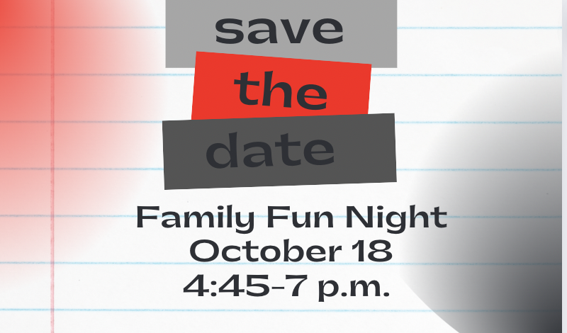

***Save the Date!***

***Help Rippleside Collect!***

Rippleside once again will be participating in the Box Tops, Loaves4Learning and pop tab collection programs.

Pop tabs are collected in each classroom and tallied at the end of the school year by the Aitkin Lions to benefit the Ronal McDonald House.

Loaves4Learning labels are found on County Hearth bread bags and can be collected at the Rippleside office which then get submitted to the company for a monetary value to benefit Rippleside students.

Box Tops have converted their program to an online submission process using your smartphone. You may still have cut out Box Tops at home, and if the expiration date has not yet been reached, they can be turned into the Rippleside office. All scannable Box Tops need to be submitted by scanning your receipt into the Box Tops app. Look for this symbol in your App store to start submitting today! All submissions go directly to benefit Rippleside students.

Inter-State Studios will be available for pictures during Entrance Conferences on Tuesday, September 6th from 8:00-4:00 and Wednesday, September 7th from 7:30-7:30.

***Inter-State WILL NOT be available on Thursday, September 8th.***

Please use order code: ***70615WF***

<https://inter-state.com/FlyerEntry/70615WF>

\****Pictures can still be ordered AFTER picture day\****

***Picture Day!***

***Volunteers Welcome!***

**

All families in the district are encouraged to complete an Application for Education Benefits (free and reduced lunch application) regardless of income. Our district receives funding based on applications received so all families are asked to apply, regardless of whether or not you think you qualify.

If you plan to send your student with a packed lunch from home and have them purchase an ala carte milk from the cafeteria, your family lunch account will be charged $.40 for each milk purchased. Payments on lunch accounts can be made through your Parent Portal app or accepted at the Rippleside Office (cash or check only).

Welcome back volunteers! If you are interested in becoming a volunteer to help in the classroom or with a school function, please complete a Volunteer Form (found at the Rippleside Office or on our website). Forms can be returned to the Rippleside Office or emailed to bgalbraith@isd1org. A form must be on file prior to volunteering so a background check can be completed. Please communicate directly with classroom teachers for volunteer opportunities in their room.

Please contact the office at 218-927-4838 if you have any questions.

Thank you to all of our returning volunteers and to all new volunteers that will be joining us this year! You are truly valued by all Rippleside staff!

**Kindergarten breakfast** – FREE

**1st – 6th grade breakfast** - $1.70

**Kindergarten - 6th grade lunch** - $2.75

**Child Guest Breakfast** - $3.00

**Adult Guest Breakfast** - $3.00

**Child Guest Lunch** - $4.95

**Adult Guest Lunch** - $4.95

Ala Carte Juice/Milk - $.40

***2022-2023 Meal Prices***

**PTO News & Events**

**Monthly Meeting**

Come to our meeting! The first meeting of the PTO will be on Monday, September 19th starting at 5:30PM in the Media Center.

The meetings are usually held on the 3rd Monday of each month. Everyone is welcome!

No separate childcare, however kids are welcome at the meetings.

WELCOME new PTO President, Carrie Baierl! Also, other new members Denise Wille and Shelly Nelson!

Still seeking more people to help on PTO. All elected positions are filled, but it is nice to hear people’s ideas and get help with events.

Look for our table set up at Entrance Conferences and we will also have a photo booth available!

**Conferences**

Thanks for all the generous donations last year. We will continue to keep the PayPal and Venmo sites active throughout the year and will be accepting donations, also.

We will have new fundraisers coming this year. Any ideas are welcome!

**Thanks/Fundraisers**

**Golden Gobbler Award**

Each month parents and Rippleside staff members will be able to nominate any employee (teacher, custodian, bus driver, paraprofessional, secretary, etc.) of Rippleside that they think has done an exceptional job.

*Nomination slips can be found at the Rippleside Office.*

**2022-2023 School Calendar**

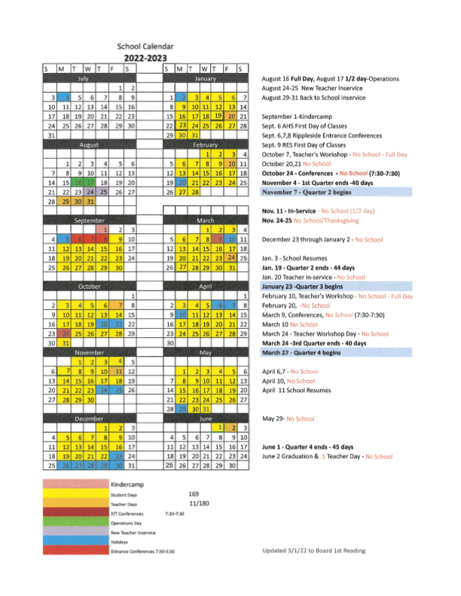



**5th & 6th Grade Tackle Football**

Are you ready for some football?? The tackle football program has after school practices and games on Saturdays with area schools. Saturday schedules will be given out the first week of practice. ALL tackle football players must have a sports physical before the start of the season. The physicals are good for 3 years. All players will walk to the fieldhouse after school to change. Practice will start at 4:00PM.

***When: Mondays/Wednesdays Aug. 29 – Oct. 19***

***Time: 4:00 – 6:30PM***

***Who: Boys and girls in grades 5 and 6***

***Where: Behind Rippleside***

***Cost $55***

**Elementary Boys Volleyball**

New this year! We are having a volleyball program for the boys! Come learn the game and have fun playing volleyball! The Minnesota State High School League is working to make in a sanctioned sport, so let’s get these boys playing!

***When: Tuesdays/Thursdays, Sept. 13 – Oct. 18***

***Time: 4:45 – 6:15***

***Who: Boys in grades 5 & 6***

***Where: Rippleside Gyms***

***Cost: $25***

**Elementary Gymnastics**

We normally begin gymnastics in the fall, but are excited with the news that the instructor Jillian is expecting her first child! Therefore, we will not be offering gymnastics until January. Watch for more information in the Winter Accent.

**2nd – 4th Grade Flag Football**

This program is designed to introduce boys and girls to the fundamentals of the sport. More time will be spent on skills and techniques, with the opportunity to scrimmage with each other throughout the season.

***When: Tuesdays/Thursdays Sept. 13 – Oct. 18***

***Time: 5:00 – 6:30PM***

***Who: Boys and girls in grades 2-4***

***Where: Behind Rippleside***

***Cost $25***

**Mixed Media Art**

Join Sue Kanz as she walks the young artists through various projects using different mediums. This class will start and end in one day with the students being able to bring their creations home at the end of the class.

***When:***

Grades 1/2 - Monday October 3

Grades 3/4 - Monday October 10

Grades 5/6 - Monday October 17

***Time***: ***3:15-5:30PM***

***Where***: ***Rippleside Art Room***

***Cost***: ***$12***

**Community Education News**



**Bowling Leagues**

Bowling at Aitkin Lanes is a kid favorite! The bowling season is 20 weeks and will work around the school calendar. Any weather-related cancellations will be made up at the end of the season. We realize that payment in full at the start of the year might be difficult, so please call Lara at 927-7736 if you would like to split the payments into 2 (one payment of $200 due at the start of the season, a 2nd payment of $125 due by December 2nd.) This payment plan can only be done over the phone. The registration fee gets student transportation to the bowling alley, bowling games, snack and USBC fees.

***Cost: $325***

***Class size: Max of 24 kids in each session***

***Time: 3:15 – 4:45 for grades 1-6***

***When:***

***Grades 5-6: Thursdays, Sept. 29 – March 6***

***Grades 3-4: Wednesdays, Sept. 28 – Feb. 15***

***Grades 1-2: Tuesdays, Sept. 27 – Feb. 14***



**Elementary Girls Volleyball**

Girls in grades 3-6 will get an introduction to the sport of volleyball in a fun after school environment! They will learn basic volleyball skills and techniques. Girls in 5th and 6th grades will have the option to go to Saturday tournaments in nearby cities.

***3rd & 4th Grade Girls Volleyball***

***When: Mondays/Wednesdays, Sept. 12 – Oct. 19***

***Time: 4:00 – 5:30PM***

***Where: Rippleside Gyms***

***Fee: $25***

***5th Grade Girls Volleyball***

***When: Tuesdays/Fridays, Sept. 13 – Oct. 18***

***Time: 3:15 – 4:45PM***

***Where: Rippleside Gyms***

***Fee: $25***

***6th Grade Girls Volleyball***

***When: Mondays/Thursdays, Sept. 12 – Oct. 19***

***Time: 3:15 – 5:00***

***Where: Rippleside Gyms***

***Cost: $25***

**Community Education News**



Sept. 6th-8th Entrance Conferences

Sept. 9th – 1st Day of Classes

Sept. 19th – PAC Meeting 5:00 in Media Center

Sept. 19th – PTO Meeting 5:30 in Media Center

Sept. 22nd - Farm2School Lunch

***SEPTEMBER MENU***



**If you haven’t friended our Rippleside Elementary PTO page on Facebook, make sure you do right away! On their page you will find helpful reminders and also a link to many of our classroom teacher’s Wish Lists on Amazon. Any orders placed will be delivered directly to Rippleside and if you shop through AmazonSmile and select Rippleside Elementary School as your charity, a portion of your purchase will be given back to help support the PTO!**

**Adopt a Teacher**