31 OCTOBER | 1 TUE | 2 WED | 3 THURS | 4 FRI
 | Day 2  HAM OMELET  or CEREAL, FRUIT  JUICE & MILK  ************  TATOR TOT HOTDISH  VEGGIES  FRUIT | Day 3  HEALTHY HUMP DAY  STRAWBERRY SMOOTHIE, HOMEMADE GRANOLA  or CEREAL, FRUIT  JUICE & MILK  ************  CHICKEN NOODLE SOUP  OYSTER CRACKERS  GARLIC BREAD  FRUIT | Day 4  “RIPP” GRIDDLE  or CEREAL, FRUIT  JUICE & MILK  ************  ANDY’S FAVORITE BUFFALO CHICKEN  MAC & CHEESE  CAESAR SALAD  FRUIT | Day 1  CHOCOLATE DONUT  or CEREAL, FRUIT  JUICE & MILK  ***********  JAVIER’S BEEF BURRITO BOWL  w/ALL THE TOPPINGS  PINTO BEANS  RICE  FRUIT
7 MON | 8 TUE | 9 WED | 10 THURS | 11 FRI
Day 2  CINNAMON BUTTER TOAST  or CEREAL, FRUIT  JUICE & MILK  ************  CHICKEN TACO BAKE  w/ALL THE TOPPINGS  FRUIT | Day 3  BANANA BREAD  or CEREAL, FRUIT  JUICE & MILK  ************  SMOKED PULLED PORK SANDWICH  SUN CHIPS  PICKLES AND FRUIT | Day 4  HEALTHY HUMP DAY  WHOLE WHEAT PANCAKES, SYRUP & TURKEY SAUSAGE  or CEREAL, FRUIT  JUICE & MILK  ************  FLATBREAD PIZZA  STRAWBERRY BANANA SALAD  CUCUMBERS & BABY CARROTS  RANCH DIP | Day 1  DONUT  YOGURT  or CEREAL, FRUIT, JUICE & MILK  ************  CHEESEBURGER  FRENCH FRIES  FRUIT  COOKIE | 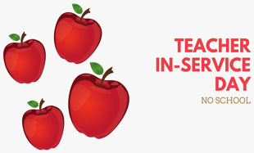  NO SCHOOL
14 MON | 15 TUE | 16 WED | 17 THURS | 18 FRI
Day 2  SCRAMBLED EGGS, AMERICAN FRIES  or CEREAL, FRUIT  JUICE & MILK  ************  HAMBURGER GRAVY  MASHED POTATOES  VEGGIES  FRUIT | Day 3  BANANA CHOCOLATE CHIP MUFFIN & YOGURT  or CEREAL, FRUIT  JUICE & MILK  *************  CHICKEN FINGERS  VEGGIES  FRUIT | Day 4  HEALTHY HUMP DAY  CHOCOLATE CHIP OATMEAL  or CEREAL, FRUIT  JUICE & MILK  ************  CHICKEN FAJITA  w/ALL THE TOPPINGS  FRUIT | Day 1  FARM2SCHOOL LUNCH  CINNAMON BUTTER TOAST  or CEREAL, FRUIT  JUICE & MILK  ************  PULLED PORK SANDWICH  COLESLAW  FRUIT | Day 2  CHOCOLATE DONUT  YOGURT  or CEREAL, FRUIT  JUICE & MILK  ************  ITALIAN PIZZA  CAESAR SALAD  FRUIT
21 MON | 22 TUE | 23 WED | 24 THURS | 25 FRI
Day 3  CINNAMON RAISIN BREAD  or CEREAL, FRUIT  JUICE & MILK  ************  KIM’S CALIFORNIA SKILLET  VEGGIES  FRUIT | Day 4  BANANA BREAD  or CEREAL, FRUIT  JUICE & MILK  ************  HOT DOG  TATOR TOTS  COWBOY BEANS  FRUIT | Day 1  PANCAKES  or CEREAL, FRUIT  JUICE & MILK  ************  SOFT CHICKEN TACOS  w/ALL THE TOPPINGS  BLACK BEAN SALSA  FRUIT  COOKIE | 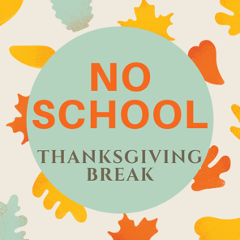  NO SCHOOL | NO SCHOOL
28 MON | 29 TUE | 30 WED
Day 2  SAUSAGE, EGG & CHEESE  or CEREAL, FRUIT  JUICE & MILK  ************  CHICKEN FRIED RICE  STIR FRY VEGGIES  MANDARIN SALAD  FORTUNE COOKIE | Day 3  DONUT  or CEREAL, FRUIT  JUICE & MILK  ************  GOULASH  GARLIC BREAD  GARDEN SALAD  FRUIT | Day 4  MYSTERY DAY!  *********** | 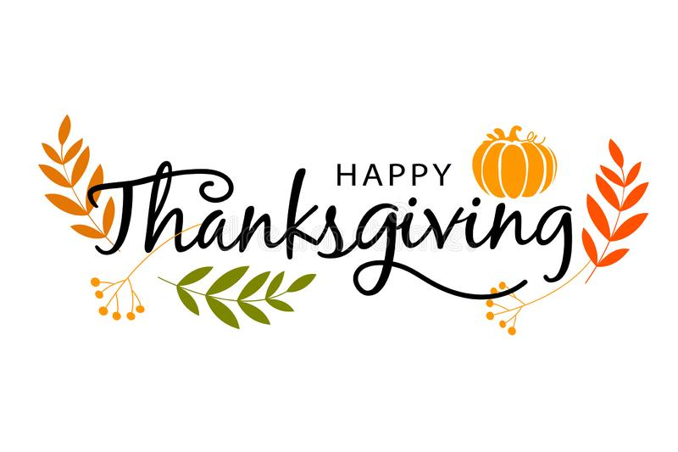
Rippleside GLUTEN-FREE November 2022 Menu

% OR CHOC MILK OFFERED DAILY FOR BKFT AND LUNCH. LACTOSE MILK OFFERED UPON PARENT REQUEST.
JUICE AND FRUIT OFFERED WITH EACH BKFT and CEREAL INSTEAD OF BREAKFAST ENTRÉE. ALA CARTE MILK/JUICE $.40
MENU SUBJECT TO CHANGE WITHOUT NOTICE
THIS IS AN EQUAL OPPORTUNITY PROVIDER

