p |  | 1 WED | 2 THURS | 3 FRI
 |  | Day 2  CHOCOLATE SCONE  YOGURT  or CEREAL, FRUIT  JUICE & MILK  ************  ROASTED TURKEY  MASHED POTATOES & GRAVY  VEGGIES  DINNER ROLL w/BUTTER | Day 3  “RIPP” GRIDDLE  w/MAPLE SYRUP  or CEREAL, FRUIT  JUICE & MILK  ************  TACO MAC  VEGGIES | Day 4  CINNAMON ROLLS  YOGURT  or CEREAL, FRUIT  JUICE & MILK  ************  CHEESE PIZZA  CAESER SALAD
6 MON | 7 TUE | 8 WED | 9 THURS | 10 FRI
Day 1  MYSTERY DAY! | Day 2  PANCAKES w/MAPLE SYRUP & SAUSAGE LINKS  or CEREAL, FRUIT  JUICE & MILK  ************  GRILLED CHEESE  TOMATO SOUP  ICE CREAM SANDWICH | Day 3  LEMON STREUSEL BREAD  YOGURT  or CEREAL, FRUIT  JUICE & MILK  ************  TURKEY & POTATO CHOWDER  GARLIC BREAD  GARDEN SALAD | Day 4  SAUSAGE, EGG & CHEESE CROISSANT  or CEREAL, FRUIT  JUICE & MILK  ************  MAC & CHEESE  POPCORN CHICKEN  VEGGIES | Day 1  MYSTERY BREAKFAST!  or CEREAL, FRUIT  JUICE & MILK  ************  TACO PIZZA  RANCH SALAD
13 MON | 14 TUE | 15 WED | 16 THURS | 17 FRI
Day 2  CHOCOLATE CHIP MUFFIN  YOGURT  or CEREAL, FRUIT  JUICE & MILK  ************  GARLIC CHEESE BREAD  MARINARA SAUCE  CARROTS & CUCUMBERS | Day 3  HAM & CHEESE OMELET  or CEREAL, FRUIT  JUICE & MILK  *************  BBQ PULLED PORK SANDWICH  BROCCOLI SALAD  COOKIES & ICE CREAM | Day 4  SAM’S BANANA BREAD!  YOGURT  or CEREAL, FRUIT  JUICE & MILK  ************  TURKEY BITES w/GARLIC CREAM SAUCE OVER NOODLES  ROASTED VEGGIES | Day 1  TACO BREAKFAST BURRITO  or CEREAL, FRUIT  JUICE & MILK  *************  FARM2SCHOOL  HAMBURGER GRAVY  MASHED POTATOES  ROASTED VEGGIES | Day 2  CHOCOLATE DONUT  YOGURT  or CEREAL, FRUIT  JUICE & MILK  ************  CARNITA FAJITA’S  PICO DE GALLO  w/ALL THE TOPPINGS
20 MON | 21 TUE | 22 WED | 23 THURS | 24 FRI
Day 3  MYSTERY DAY! | Day 4  CHEESY SCRAMBLED EGGS & BACON  or CEREAL, FRUIT  JUICE & MILK  ***********  SARAH’S BBQ CHICKEN SANDWICH  VEGGIES | Day 1  FRENCH TOAST STICKS  MAPLE SYRUP  or CEREAL, FRUIT  JUICE & MILK  ************  ROASTED TURKEY  MASHED POTATOES  GRAVY  ROASTED VEGGIES  DINNER ROLL w/BUTTER | Day 2  CINNAMON TEXAS TOAST  HOT CHOCOLATE w/MARSHMALLOWS  or CEREAL, FRUIT  JUICE & MILK  ************  PORKY TOTS  w/CHEESE  VEGGIES | Day 3  MYSTERY BREAKFAST!  or CEREAL, FRUIT  JUICE & MILK  ************  BEEF TACO NACHO’S  w/ALL THE TOPPINGS
27 MON | 28 TUE | 29 WED | 30 THURS
NO SCHOOL!  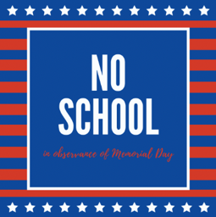 | Day 4  MYSTERY DAY! | Day 1  MYSTERY DAY! | Day 2  MYSTERY BREAKFAST!  or CEREAL, FRUIT  JUICE & MILK  ************  AITKIN LION’S PICNIC!  GRILLED HOT DOGS  POTATO CHIPS  PICKLE  FRUIT JUICE
Rippleside May 2024 Menu

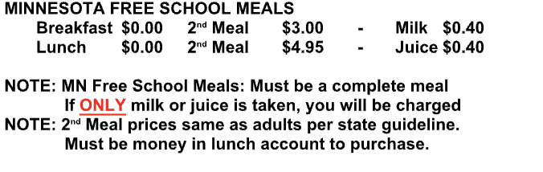

MENU SUBJECT TO CHANGE WITHOUT NOTICE
THIS IS AN EQUAL OPPORTUNITY PROVIDER
*Sandwich option available upon request*

