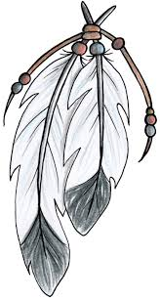
AITKIN’S AMERICAN INDIAN
Program and Committee

Currently the Aitkin school district connects with each American Indian student in our district through a monthly check and connect with their school counselor. This is to build relationships and identify and provide support/resources as needed. We would like your input on our American Indian programming.

At this time our district receives approximately $21,000.00 to provide support, guest speakers, and other resources for our Indian Education Programming at the Aitkin School District.

What is LAIEPC?
LAIEPC stands for Local American Indian Education Parent Committee

LAIEPC feels strongly that in order to address the concerns, parents need to speak up and participate in the solution and the school needs to provide leadership and support in order to assist our students.

- Today approximately 2% of Aitkin’s students are American Indian.

LAIEPC’s Goals
- Provide student support services to all American Indian Students K-12, to ensure academic success.
- Provide an administrative and cultural voice in special education, 504 Accommodation Plans, curriculum development and classroom management.
- Increase knowledge and appreciation of Ojibwe history, language and culture to ALL students and staff.
- Provide interactive cross-cultural activities to promote positive relationships with Aitkin students, parents, staff and community.
- Seek outside funding to assist in payment of salaries and program needs.
- Expand American Indian Education programs to increase student leadership, community building and service learning opportunities.

If you have any questions or would like to be part of the committee, please call Lisa DeMars, Aitkin’s District Indian Education, Curriculum, and Assessment Coordinator at (218) 297-3046 or (320) 292-9944 or ldemars@isd1.org

